CHAPTER 9: FUTURES ARBITRAGE STRATEGIES

END-OF-CHAPTER QUESTIONS AND PROBLEMS

1. (Delivery Options) The U.S. Treasury bond futures contract contains several imbedded options. First, the wild card option results from a difference in the closing times of the spot and futures markets. The Treasury bond futures contract stops trading at 3:00 p.m. Eastern time. The spot market for Treasury bonds operates until 5:00 p.m. Eastern time. The wild card option is the opportunity the holder of the short futures contract has to lock in the invoice price at 3:00 p.m. and make delivery if the spot price falls below the established invoice price between 3:00 p.m. and 5:00 p.m. The option exists only during the delivery month.

Second, the holder of the short position has the right to deliver any of a number of acceptable bonds, known as the quality or switching option. Sometimes the holder of the short position will be holding a bond that is not the best to deliver. A profit is sometimes possible by switching to another bond.

Third, because the last day for trading a T-bond futures contract is the eighth-to-last business day of the delivery month and delivery can take place during the remaining business days, there is an end-of-the-month option. The invoice price during those final delivery days is based on the settlement price on the last trading day. Thus, during the last seven delivery days, the holder of the short position has full knowledge of the price that would be received for delivery of the bonds. This gives the holder of the short position the opportunity to watch the spot market for a fall in bond prices. The trader can continue to wait for spot prices to fall until the second-to-last business day, because delivery must occur by the last business day.

Fourth, since the short is often permitted to make delivery on any day during the delivery month, she holds a timing option. The timing option is the opportunity the holder of the short futures contract has to deliver at any time during the expiration month. Early delivery is made if the cost of financing exceeds the coupon on the bond and later delivery is made if the coupon exceeds the cost of financing.

2. (Treasury Bond Futures Spreads and the Implied Repo Rate) The implied repo rate on a spread is the implied cost of establishing a cash-and-carry position at the expiration of the earlier futures contract of the spread.

Suppose there is a futures contract expiring in ¼ of a year and another expiring ½ of a year. Suppose today we sell the ½ year U.S. Treasury bond futures contract and buy the ¼ year U.S. Treasury bond futures contract. In ¼ of a year, the shorter-term contract expires. We take delivery of the bond, financing it at the repo rate, r, and hold it for another ¼ of a year, when the longer-term contract expires. Because we are short that contract, we simply deliver the bond.

3. (Foreign Exchange Arbitrage) Interest rate parity can be expressed in two ways based on how interest rates are quoted. The model for the foreign exchange futures price based on local currency per unit of foreign currency and annual compounding is

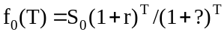

where S₀ is the spot foreign exchange rate expressed in local currency per unit of foreign currency, r denotes the domestic risk free interest rate (annually compounded) and denotes the foreign risk free interest rate (annually compounded). The continuously compounded version is expressed as

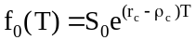

where r_{c} is the continuously compounded risk-free rate and 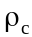 is the continuously compounded foreign interest rate. Recall that in equilibrium,

Thus,

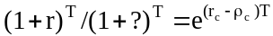

or

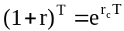 and 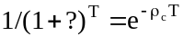

4. (Stock Index Arbitrage) Program trading, as defined by the NYSE, is the simultaneous purchase or sale of at least 15 stocks with a total market value of at least $1 million. One consequence of program trading is that large stock price movements often occur quickly and without an apparent flow of new information. Also, some argue that program trading is to blame for increased volatility in the spot markets.

5. (Carry Arbitrage and the Implied Repo Rate) By definition an arbitrage transaction must be riskless. In a carry arbitrage transaction, the investor purchases the underlying security in the spot market and sells a futures contract. Hence the security’s sale price is fixed, given that it is held to expiration. Because the arbitrageur’s transactions are financed completely by borrowing, and given his contract’s fixed future sale price, there is no risk involved and no risk premium is warranted.

6. (Stock Index Arbitrage) We are given: f₀(T) = 1,376.42, S₀ = 1,371.00, r_{c} = 0.0512, and T = (55/365). In order to solve for the implied interest rate, we must first solve for the continuously compounded dividend yield using:

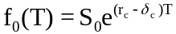

Solve for 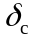:

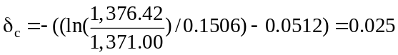

Thus, the dividend yield is 2.5 percent on an annualized, continuously compounded basis.

7. (Foreign Exchange Arbitrage, Chapter 8 Review) We are given S₀ = 0.7873, r = 0.0536, ρ = 0.0311, and T = 8/12. The model for the foreign exchange futures price, adjusted for semi-annual compounding is:

f₀(T) = S₀(1 + r/2)^{2T}/(1 + ρ/2)^{2T}

Here,

F₀ = 0.7873(1 + (0.0536/2))^{2(8/12)}(1 + (0.0311/2))^{-2(8/12)} = 0.79895

Therefore, the forward rate should be about 0.79895 euros.

8. (Foreign Exchange Arbitrage, Chapter 8 Review) We are given S₀ = 0.7873, r = 0.0536, ρ = 0.0311, and T = 8/12. The model for the foreign exchange futures price is:

f₀(T) = S₀(1 + r)^{T}/(1 + ρ)^{T}

Therefore, on February 4, the forward rate should have been

f₀(T) = 0.7873(1 + 0.0536)^{8/12}(1 + 0.0311)^{-8/12} = 0.79871

Thus, the forward price is slightly lower due to the marginal effect of annual compounding as opposed to semi-annual compounding. Although the difference is slight here, at times, the method of compounding can have a significant impact of the theoretical price.

9. (Federal Funds Futures Carry Arbitrage and the Implied Repo Rate) The arbitrage can be illustrated with the following table:

Date | Spot Market | Futures Market
November 1 | Borrow present value of $5,000,000 at one month LIBOR ($4,983,389);  Lend same amount at two month LIBOR | Sell one December Fed funds futures contract at 94.75.
December 1 | Repay borrowing (–$5,000,000)  Payoff present value of loan | Buy one December Fed funds futures contract to offset initial futures position.
The key insight is that the payoff required on December 1st of the two month LIBOR loan depends on the one month LIBOR rate observed on December 1st. Also, we assume no basis risk between one-month LIBOR rates and Fed funds futures implied rates as long as we are not in the delivery month. The loan balance due on January 1st is:
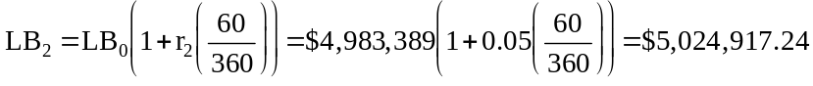
Assuming the one-month LIBOR rate observed on December 1st is 7 percent, then the present value of the initial two-month loan after one month is:
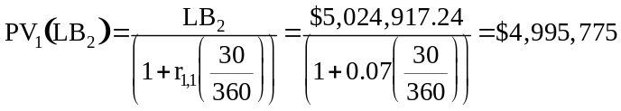
Assuming no basis risk, the Fed funds futures price in one month is 92.75 (=100 – 7 – 0.25). Therefore, the gain on the Fed funds futures contract is $8,333 (=(94.75 – 92.75)x($5,000,000)x(30/360)/100). Adding the gain on the futures contract with the proceeds from the present value of the two-month loan, we have $5,004,108 (=4,995,775 + 8,333). Paying off the one-month loan provides arbitrage profits of $4,108. The implied one-month repo rate, therefore, is

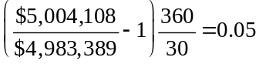

or 5 percent. The one-month LIBOR rate is 4 percent, indicating the potential arbitrage opportunity.

10. (Federal Funds Futures Carry Arbitrage and the Implied Repo Rate) Again, the arbitrage can be illustrated with the following table:

Date | Spot Market | Futures Market
November 1 | Borrow present value of $5,000,000 at one month LIBOR ($4,983,389);  Lend same amount at two month LIBOR | Sell one December Fed funds futures contract at 94.75.
December 1 | Repay borrowing (–$5,000,000)  Payoff present value of loan | Buy one December Fed funds futures contract to offset initial futures position.
The payoff required on December 1st of the two month LIBOR loan depends on the one month LIBOR rate observed on December 1st. Also, we assume no basis risk between one-month LIBOR rates and Fed funds futures implied rates as long as we are not in the delivery month. As before, the loan balance due on January 1st is:
Assuming the one-month LIBOR rate observed on December 1st is 5.5 percent, then the present value of the initial two-month loan after one month is:
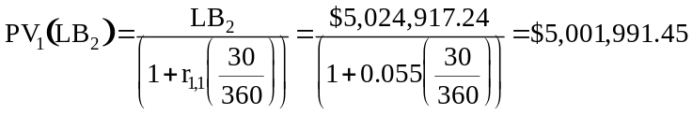
Assuming no basis risk, the Fed funds futures price in one month is 94.25 (=100 – 5.5 – 0.25). Therefore, the gain on the Fed funds futures contract is $2,083.33 (=(94.75 – 94.25)x($5,000,000)x(30/360)/100). Adding the gain on the futures contract with the proceeds from the present value of the two-month loan, we have $5,004,074.78 (=5,001,991.45 + 2,083.33). Paying off the one-month loan provides arbitrage profits of $4,074.78. The implied one-month repo rate, therefore, is

or 4.98 percent. The one-month LIBOR rate is 4 percent, indicating the potential arbitrage opportunity. The arbitrage is slightly lower if subsequent rates are lower, hence the profitability of this arbitrage depends somewhat on the subsequent behavior of interest rates.

11. (Eurodollar Arbitrage) If she lends for 180 days, she will receive the following amount at maturity:

$20,000,000(1 + 0.0615(180/360)) = $20,615,000,

which would be an annualized rate of return of

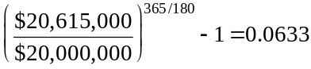

Now compare to the alternative of lending $20 million for 90 days and buying 20 futures contracts.

Day 0
Lend $20 million for 90 days at 6%
Buy 20 futures contracts at a price as follows:
IMM Index = 93.75
Futures price = 100 – (100 – 93.75)(90/360) = 98.4375
Actual price = $984,375

Day 90
Payoff of 90 day loan:
$20,000,000(1 + 0.06(90/360)) = $20,300,000
Sell 20 futures at a price as follows:
LIBOR = 5.9 percent, meaning the IMM Index is 94.10
Futures price = 100 – (100 – 94.10)(90/360) = 98.525
Actual price = $985,250
Profit on futures = 20($985,250 – $984,375) = $17,500
Total funds available: $20,300,000 + $17,500 = $20,317,500
Roll over this amount into a new 90-day loan at 5.9%

Day 180
Payoff of 90 day loan:
$20,317,500(1 + 0.059(90/360)) = $20,617,183
Annualized return on loan:

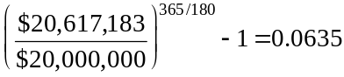

So the alternative is worth two additional basis points.

12. (Determining the Cheapest-to-Deliver Bond on the Treasury Bond Futures Contract) Days between 9/26 and 3/1: 156
Days between 11/15 and 3/1: 106

a. Future value of reinvested coupon of 11/15:
(12.75/2)(1.053)^{(106/365)} = 6.47

Spot price factored up by cost of carry:
(148.28125 + 4.64)(1.053)^{(156/365)} – 6.47 = 149.86

Invoice price: 94.6875(1.4433) + 3.73 = 140.39
Difference: 140.39 – 149.86 = –9.47

b. Future value of reinvested coupon of 11/15:
(13.875/2)(1.053)^{(106/365)} = 7.04

Spot price factored up by cost of carry:
(159.84375 + 5.05)(1.053)^{(156/365)} – 7.04 = 161.53

Invoice price: 94.6875(1.5689) + 4.06 = 152.62

Difference: 152.62 – 161.53 = –8.91

Bond B is cheaper to deliver but might not be the cheapest overall if other bonds were considered.

13. (Determining the Cheapest-to-Deliver Bond on the Treasury Bond Futures Contract) Days between 8/20 and 12/14: 116

a. Days between 11/15 and 12/14: 29

Future value of reinvested coupon of 11/15:
(9/2)(1.079)^{(29/365)} = 4.53

Spot price factored up by cost of carry:
(100.4375 + 2.37)(1.079)^{(116/365)} – 4.53 = 100.79

Invoice price: 89.375(1.1106) + 0.72 = 99.98

Difference: 99.98 – 100.79 = –0.81

b. (No coupons between 8/20 and 12/14)

Spot price factored up by cost of carry:
(121.4375 + 0.15)(1.079)^{(116/365)} = 124.56

Invoice price: 89.375(1.3444) + 3.70 = 123.86

Difference: 123.86 – 124.56 = –0.70

Bond Z is cheaper but might not be the cheapest overall if other bonds were considered.

14. (Implied Repo, Carry Arbitrage and Treasury Bond Futures) We need to find the value of AI, the accrued interest on the bond on March 16 and AI_{T}, the accrued interest on the bond on June 1. The bond has coupon payment dates of November 15 and May 15. This is a period of 181 days. From November 15 to March 16 is 121 days. Thus, the accrued interest on March 16 is

(14/2)(121/181) = 4.6796

The accrued interest on June 1 is slightly more complex. Since a coupon was paid on May 15, which is during the holding period from March 16 to June 1, we must allow the coupon to be reinvested for 17 days. This equals (14/2)(1.055)^{(17/365)} = 7.02, the compound value of the reinvested coupon. Then there is 17 days of accrued interest on the next coupon or (14/2)(17/184) = 0.65 (based on 184 days between May 15 and November 15).

The length of the holding period is 77 days or 77/365 = 0.211. The current spot price is 161.71875. Thus, the implied repo rate is

= [((100.53125)(1.584) + 0.65 + 7.02)/(161.71875 + 4.68)]^{1/0.211} – 1 = 0.0147

The implied repo rate is 1.47 percent. This means that the transaction would be profitable if a repo could be obtained at a rate of less than 1.47 percent, which is unlikely. Transaction costs would also have to be covered.

15. (Stock Index Arbitrage) f₀(T) = 394.85, S₀ = 392.54, r_{c} = 0.0283, δ = 0.0208

The time to expiration is from July 5 to September 20–77 days–so

T = 77/365 = 0.211.

The theoretical futures price is

f₀(T) = 392.54e^{(0.0283 - 0.0208)(0.211)} = 393.16.

At 394.85, the futures contract is overpriced. An arbitrageur would sell the futures and buy the spot portfolio. After taking into account the cost of financing the spot position minus the dividends, the cost of the spot portfolio is 393.16. The futures contract locks in a sale price of the portfolio of 394.85. The difference of 1.69 is a risk-free arbitrage profit but must cover the transaction costs.

16. (Stock Index Arbitrage) Effective purchase price on spot (after accounting for dividends and lost interest):

392.54e^{(0.0283 - 0.0208)(0.211)} = 393.16

Profit on spot: 388.14 – 393.16 = –5.02
Profit on futures: 394.85 – 388.14 = 6.71
Net profit: 6.71 – 5.02 = 1.69

This is the amount by which the futures was originally overpriced in the previous problem. The level of the index at expiration is irrelevant because the transaction is hedged.

17. (Stock Index Arbitrage) The implied repo rate on an index arbitrage trade is the implicit rate of return on the transaction, and, thus, is the implied cost of financing. If the actual repo financing rate is less, the trade is profitable.

8/20 – 9/20: 31 days, T = 31/365 = 0.0849

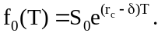

Here we solve for r, using the market price of the futures, 429.70, as f₀(T).

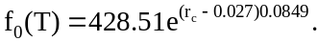

You can solve this by trial and error or by using logarithms:

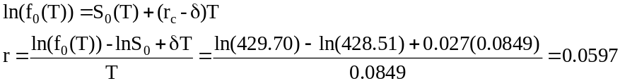

If you could get financing for less than 5.97 percent, do the trade.

18. (Determining the Cheapest-to-Deliver Bond on the Treasury Bond Futures Contract) The futures settlement price is

101 21/32 = 101.65625

The 3:00 p.m. spot price is

150 15/32 = 150.46875

The invoice price is

101.65625(1.4639) = 148.8146

Therefore, the bond price must fall by

150.46875 – 148.8146 = 1.6542

to a price of 148.8146 to justify exercise of the wild card option.

19. (Implied Repo, Carry Arbitrage and Treasury Bond Futures)From September 12 to December 1 is 80 days. Thus, T = 80/365 = 0.2192.

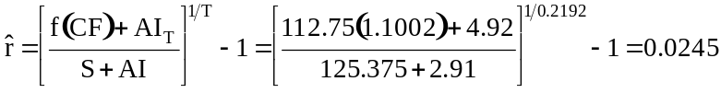

Thus a cash and carry transaction in which one purchased the bond and sold the futures would generate a risk-free return of 2.45 percent, which we call the implied repo rate. This would be attractive only if funds could be borrowed, normally in the repo (repurchase agreement) market at less than 2.45 percent, which seems highly unlikely.

20. (Implied Repo, Carry Arbitrage and Treasury Bond Futures) f₀(t) = 100.53125, CF(t) = 1.3593, AI_{t} = 3.29
f₀(T) = 99.53125, CF(T) = 1.3581, AI_{T} = 6.16
T – t = 92/365 = .2521

r = {[(99.53125)(1.3581) + 6.16)]/[100.53125(1.3593) + 3.29]}^{(1/0.2521)} – 1 = 0.04

21. (Treasury Bond Futures Spreads and the Implied Repo Rate) Recall the implied repo rate is

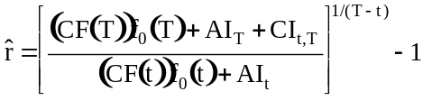

The numerator is the amount received for the bond at the maturity of the longer-dated futures contract. The denominator is the amount paid for the bond at the maturity of the shorter-dated futures contract. Dividing these two numbers gives the rate of return over the period T − t. Raising this term to the power 1/(T − t) annualizes the rate. The implied repo thus is the return we could earn over the period T − t. If the bond can be financed at less than this rate, the transaction will be profitable. We have to account for transaction cost. Because the offer price exceeds the bid price, when we use the offer price, then the implied repo rate is higher. Because we are purchasing the shorter-dated futures contract, we should use the offer price for it and the bid price for the longer-dated futures contract. Correctly accounting for transactions costs is an important component of the analysis.

22. (Treasury Bond Futures Spreads and the Implied Repo Rate) Since the time from March 7 to June 5 is 90 days, the implied repo rate is

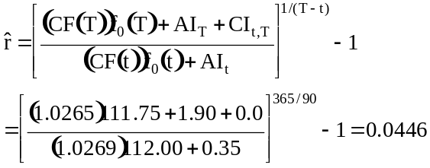

The implied forward repo rate thus is 4.46 percent. The bond could be financed at 4.00 percent, therefore the transaction would be profitable. Specifically, the trader would go long the March contract and go short the June contract. Also, the trader would enter into a forward repo contract to secure funding.

23. (Implied Repo, Carry Arbitrage and Treasury Bond Futures) The following equation is the implied repo rate based on carry arbitrage of the underlying asset.

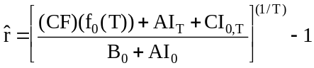

The numerator is the amount received for the bond at the expiration of the futures contract including accrued interest and any coupons paid. The denominator is the amount paid for the bond initially. Dividing these two numbers gives the rate of return over the period T. Raising this term to the power 1/T annualizes the rate. The implied repo thus is the return we could earn over the period T. If the bond can be financed at less than this rate, the transaction will be profitable.

The following equation is the implied repo rate based on carry arbitrage of a bond futures spread where the investor is short the time T maturity bond futures contract and long the time t maturity bond futures contract.

.

The numerator is the amount received for the bond at the expiration of the time T futures contract including accrued interest and any coupons paid between the expiration of the time t maturity futures contract and the time T maturity futures contract. The denominator is the amount paid for the bond based on the time t bond futures contract. Dividing these two numbers gives the rate of return over the period T – t. Raising this term to the power 1/(T – t) annualizes the rate. The implied repo thus is the return we could earn over the period T – t. If the bond can be financed at less than this rate, the transaction will be profitable.

24. (Stock Index Arbitrage) The theoretical futures price was shown to be 393.16. Based on a spot index of 392.54, the transaction costs would be 392.54(0.005) = 1.96. Thus, the actual price could be as high as 393.16 + 1.96 = 395.12 or as low as 393.16 – 1.96 = 391.20 without there being a profitable arbitrage opportunity.

